Board Meeting 10
Wednesday, 28th April 2021
Via Zoom

Attendees
Roger Williams, Coastal Housing (RW)
Richard Jones, Selections Gift Shop (RJ)
Sally Jones, Resident (SJ)
Jo Morgan, Peacocks (JM)
Nia Hall, Pump Supplies (NH)
Alice Smith, Pobl Housing (AS)
Ray Oglesby, Barista’s (RO)
Stephen Kinnock, (SK)

Apologies
Lisa smith, The Flower Box (LS)

Item | Detail | Action
1.0 | Welcome and apologies  Apologies given as above.
2.0 | Minutes of the last meeting and matters arising  2.1 Confirmation of approval  Those present agreed the minutes were a true reflection of the meeting.  2.2 Matters arising  2.2.1 Extension of free parking  MJ apologised to the board for the delay in asking NPTBC if the free parking could be extended and start a week earlier. The quote received from them was £8k. The board decided that it was too late to proceed with the initiative.
3.0 | Company matters  3.1 Attendance at board meetings  A standing item on the agenda and RW thanked board members for attending regularly. Oliver Dineen who had not attended any board meetings since becoming a Director would be asked to stand down as soon as MJ was added as a signatory on the bank account.  3.2 Bank account  MJ and RW were still in the process of being added to the bank account as signatories. They had spoken to a new manager who had assured them that it would be sorted quickly. However, that had been at least four weeks ago. SK offered to write to Barclays head office to lodge a complaint.  Oliver Dineen would be removed as a signatory once MJ was added. | SK: To write to Barclays head office to lodge a complaint
4.0 | Programme  - Coastal Communities Funding  There had been no response as yet from the fund with nothing expected until March.  - Programme  4.2.1. Gingerbread trail  The trail was up and running with good feedback received from businesses and the public so far.  4.2.2 Events – planning ahead  The board discussed when it might be possible to start planning events for 2021 in light of the vaccination programme and agreed it was extremely difficult in the circumstances. Towards the end of May might be possible to look at the outdoor market and a superhero day. MJ would look into these.  The board also discussed a campaign/trail around Mothers’ Day, Valentines Day and Easter.  The same company that offered the gingerbread trail had access to a safari trail with bigger statues that could be placed around the town centre, possible during February half term for the cost of approximately £4k. MJ would look into this depending on the lockdown rules closer to the time.  RO alerted the board to the fact that the Aberafan Shopping Centre were not communicating with businesses as well as they could be and that this had been an ongoing issue for a number of years. SK offered to write to the shopping centre owners. MJ to send contact details.  4.3 Video and advertising  4.3.1 Video featuring Di Botcher  The video had been very well received and shared widely on social media:  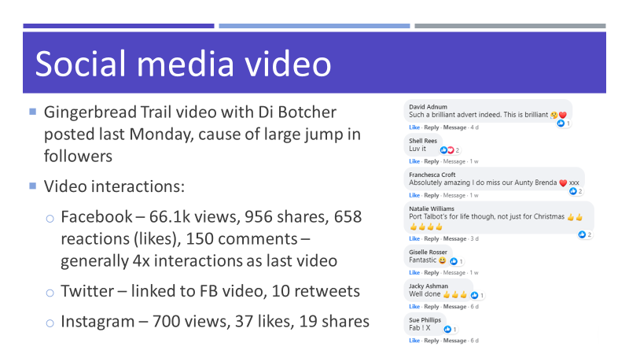  4.3.2 Subsidised videos for BID members  90 minutes filming at premises  Editing into a 30-60 second video for social media  Includes music  £199 + VAT each  The board discussed again this proposal which had been agreed at the last meeting and the merits of making the videos in January. They agreed to offer the service to the first 20 businesses that showed an interest. | MJ: To send the Aberafan Shopping Centre head office details to SK who would write to them
25.0 | Marketing  5.1 Social media  The Di Botcher video had caused a huge jump in social media followers:  - Facebook  1283 followers (+536)  - Twitter  259 followers (+14)  - Instagram  205 followers (+53)  5.2 E-newsletter  28 newsletters sent out so far:  Open rates:  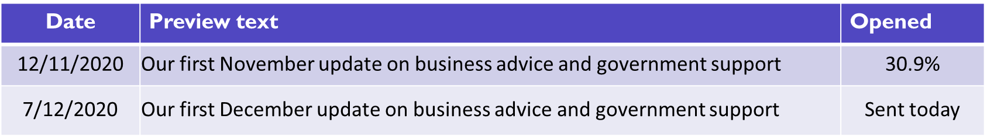  - 99 subscribers
6.0 | Finance  - Income Report  - Update on levy collection from NPTBC  NPTBC had been unable to give an up-to-date collection figure from NTBC but 27 businesses had been taken to court for not paying the levy which were a mix of independents and nationals.  Expenditure Report  No update given.
7.0 | AOB  RW, PW and MJ had me to discuss the Kick Start scheme and employing potentially two members of staff to act as town centre business engagement officers through NPTBC. The board though this was a really good idea and authorised MJ to go ahead and fill in the application form. | MJ: To fill in the application form for the Kick Start scheme

