Board Meeting 8
Monday, 4th November
Via Zoom

Attendees
Richard Jones, Selections Gift Shop (RJ)
Sally Jones, Resident (SJ)
Jo Morgan, Peacocks (JM)
Nia Hall (NH)
Alice Smith (AS)
Lisa smith, The Flower Box (LS)

Mandy Jenkins, The means (MJ)
Peter Williams, The means (PW)

Apologies
Roger Williams (RW)
Ray Oglesby (RO)

Item | Detail | Action
1.0 | Welcome and apologies  Apologies given as above.
2.0 | Minutes of the last meeting and matters arising  2.1 Confirmation of approval  Those present agreed the minutes were a true reflection of the meeting.  2.2 Matters arising  2.2.1 Nigel Hunt  RW has written to Nigel to inform him that he was no longer able to sit on the board as he was not trading from a unit in the town. NH had been in touch with MJ to say that he was in the process of looking for another unit possibly in the Aberafan Shopping Centre.  2.2.2 £1 parking  The action from the previous board meeting was to ask NPTBC if the BID was able to only subsidise parking for £1 on Saturdays in the Bethany Car Park (and not the two car parks previously discussed). However, the board had since decided not to pursue this until the new year.  MJ to ask NPTBC if the free parking could be extended for another week in December and what the coast might be to the BID.  2.2.3 Marketing quotes  Covered under 5.0.  2.2.4 Digital garage  RW had attended the event as Chair of the BID and he had reported back that it was quite successful with some town centre businesses in attendance. | MJ: To ask NPTBC about the cost pf extending the free parking
3.0 | Company matters  3.1 Attendance at board meetings  RJ reminded board members again of the importance of attending meeting. Stephanie Griffiths of the Credit Union had accepted a place on the board but had been unable to attend today.  JM was unsure what would be happening with the future of Peacocks nationally but would be happy to remain on the board as a resident of representative of the church.  3.2 Financial procedures and bank account  MJ and RW were still in the process of being added to the bank account as signatories.
4.0 | Programme  - Coastal Communities Funding  PW gave an update on the application that had been submitted to CCF. The board thanked PW for all his work and expressed excitement about the project.  - Project ideas  MJ had sent an email out listing all of the ideas below:  4.2.1 Christmas  4.2.1.1 Gingerbread trail  10 gingerbread people to be placed in businesses around town (plus in the shopping centre) for a month for kids to find as a treasure hunt. There will be maps placed on leaflet stands along with a postbox to post completed trails in the shopping centre. The idea is to drag kids/parents around town so see what different business have on offer. Each child that completes the trail gets a gingerbread biscuit from Jenkins Bakery with a token from the booklet. An overall winner is drawn at the end of the month who receives a good prize  This would cost approx. £3k any maybe a little more and would include all the printing of leaflets etc.  The board agreed this.  4.2.1.2 Virtual Santa  1 x week’s filming by Buffoon Media - £1438 plus £187.50 for a Saturday. MJ thanked NH and AS for their suggestions for a Santa.  The board decided not to proceed with this for this year as lots of placed were now doing their own grottos and visits. They did discuss the possibility of purchasing a Santa suit for businesses to borrow.  4.2.1.3 Christmas windows  Offering £25 per business to decorate windows.  The board decided against this idea.  4.2.1.4 Christmas gift vouchers  Offering each levy payer vouchers with our and their logos to save them getting their own.  One off design charge £20+vat  50 Quantity £10+vat  100 Quantity £15+vat  250 Quantity £25+vat  The board decided against this as many businesses had their own vouchers.  4.3 Video and advertising  4.3.1 Video featuring Di Botcher  £600 plus whatever fee Di might charge.  The board decided to go ahead with this and incorporate the gingerbread trail into a Christmas video.  4.3.2 Subsidised videos for BID members  90 minutes filming at their premises  Editing into a 30-60 second video for social media  Includes music  £199 + VAT each  The board decided to go ahead with this.  4.3.3 Sky advert  £3228 - £885 for a month-long advert about the Town Centre targeted at local Sky users (plus digital channels).  TV Commercial Production (Buffoon Media).  £2,290 + VAT for half day filming but it includes scripting, clearance by ClearCast, two crew on site, editing, music, voiceover and delivery to the broadcaster.  The board decided not to go ahead with this due to cost.  4.3.4 Parking  See 2.2.2.
25.0 | Marketing  MJ had spoken to three marketing agencies about taking over the marketing and social media for the BID. Only two had responded with revised quotes:  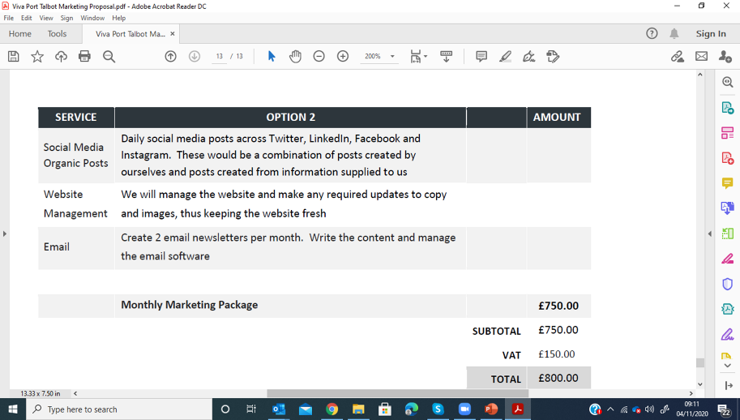  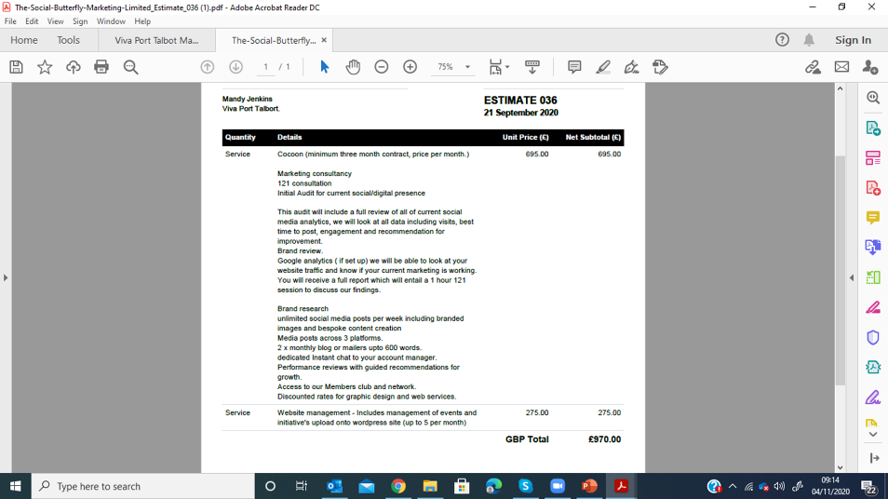  The board decided to carry on with The means for now and wait on the outcome of the CCF application.  5.1 Social media  - Facebook  751 followers (+182)  - Twitter  244 followers (+19)  - Instagram  156 followers (+29)  5.2 E-newsletter  26 newsletters sent out so far:  Open rates:  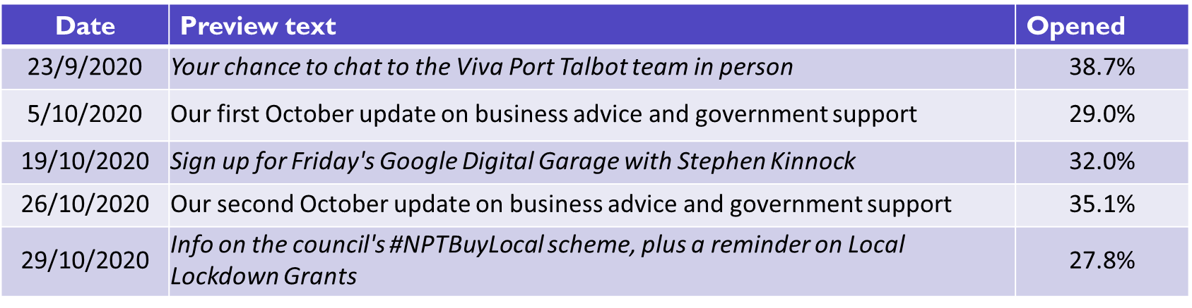  - 98 subscribers
6.0 | Finance  - Income Report  - Update on levy collection from NPTBC  MJ had sent out the following email to the board on 28th October:  Once all the current outstanding bills are paid we will be left with £12,994.61 in the bank account.  We have so far invoiced for £38, 162.33 but this includes VAT which will eventually have to pay back so in reality £31,802.11 out of £64,305.95 so in theory we still have £32,503.84 to invoice if it all comes in.  As of today, there is £11,377.28 left to come in according to the ratings department so £52,929.67 has been collected (82%) which means we can invoice for £18,627.56 (as NPTBC want to keep £2.5 in their account for refunds).  We are also waiting for NPTBC to transfer the £3,211.61 BID’s resilience grant funding from Welsh Government.  So, we will have £34,833.78 in the account of which £13,702 will be ringfenced for The means to provide management support until the end of March so £21,131.87 to be spent as things currently stand.  - Expenditure Report  No outstanding invoices to be paid.
7.0 | AOB  Nest meeting to take place on Monday, 7th December.

